Following is the Matching gray level image

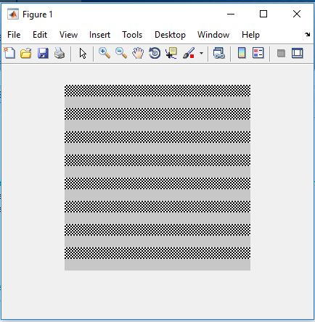

Following images contains the derivation of the equation to obtain gamma for the monitor

Here

The value of g was determined by adjusting the black level and picture until the stripe pattern disappeared from a distance as instructed in section 4.1 and 4.2 of the Gamma.pdf

g = 194

gamma = 2.5352

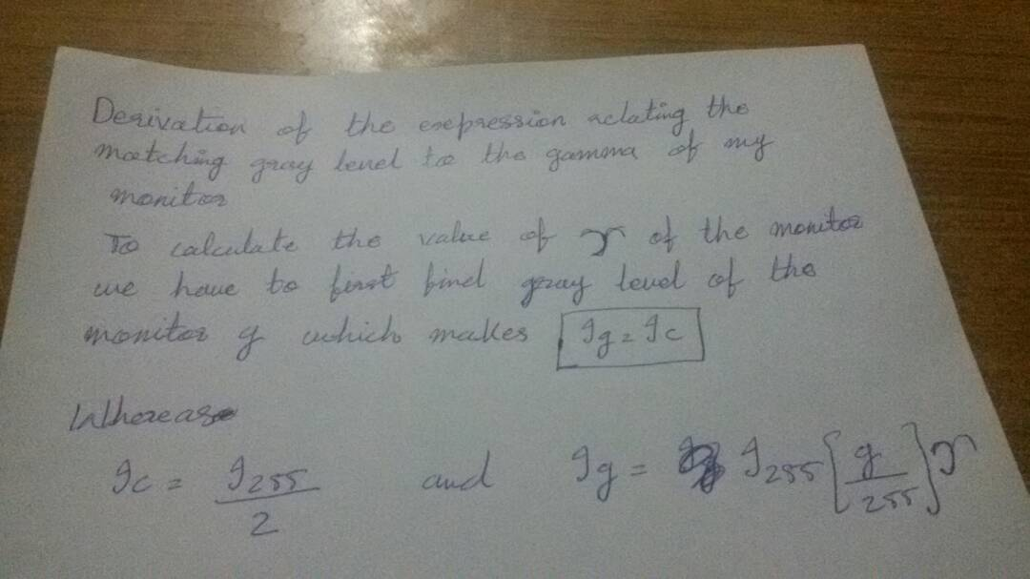

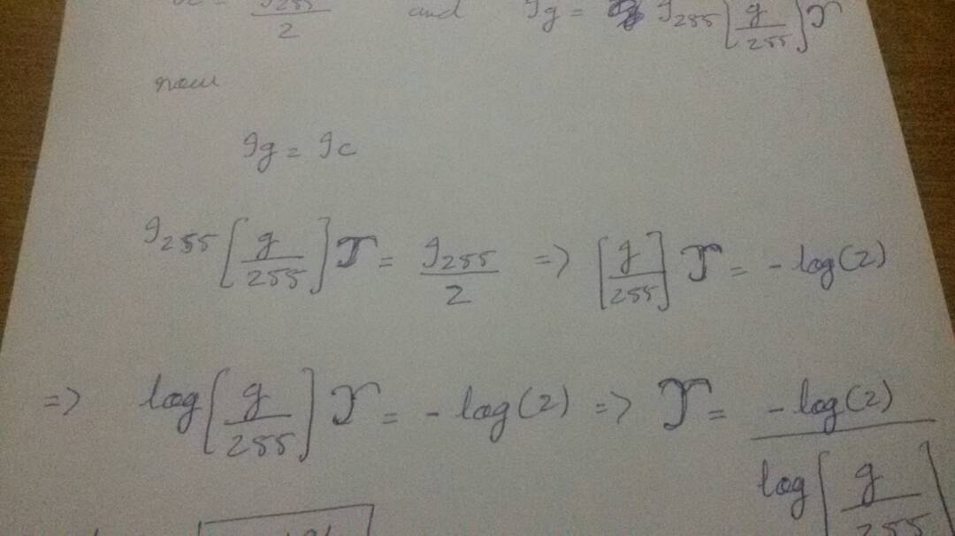

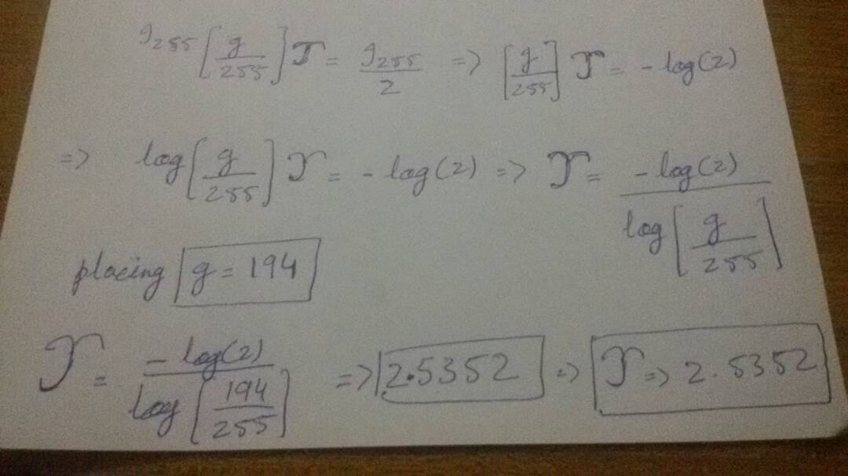

Gamma correction controls the overall brightness of an image. Images which are not corrected can look either bleached out or too dark. Suppose a computer monitor has 2.2 power function as an intensity to voltage response curve. This just means that if you send a message to the monitor that a certain pixel should have intensity equal to x, it will actually display a pixel which has intensity equal to **xy** Because the range of voltages sent to the monitor is between 0 and 1, this means that the intensity value displayed will be less than what you wanted it to be. Such a monitor is said to have a gamma of y.

So in my case formula for gamma correction,

Gamma Corrected = 255 * (Image/255)^(1/y).

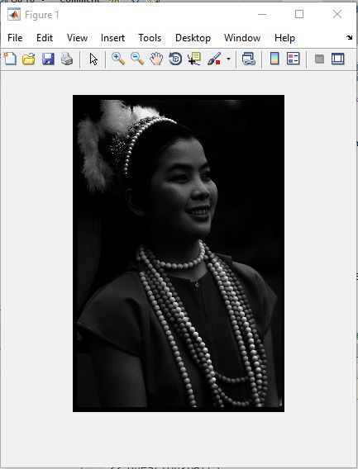

Figure 1 (Original Linear.tif)

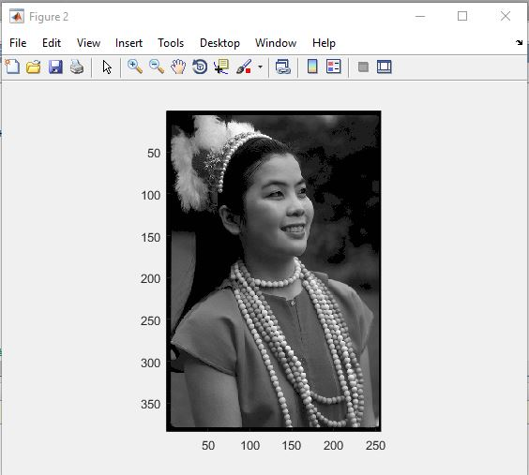

Figure 2 (Gamma Corrected Linear.tif)